**ES6 ASSIGNMENT**



<!DOCTYPEhtml>

<html>

    <head>

        <title>demo</title>

    </head>

    <head>

    <body>

        <h3>constant declaration</h3>

        <scriptsrc=index.js>

        </script>

    </body>

    </head>

</html>

constobj1={

    name:"puja"

};

console.log(obj1.name);

obj1.name="kumari";

console.log(obj1.name);



<!DOCTYPEhtml>

<html>

    <head>

        <title>demo</title>

    </head>

    <head>

    <body>

        <h3>Variable declaration inside if block</h3>

        <script>

            vara = 1;

            varb = 2;

            if(a===1){

                vara=20;

                varb=10;

                document.write(a,"<br>");

                document.write(b,"<br");

            }

        </script>

    </body>

    </head>

</html>

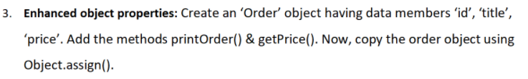

<!DOCTYPEhtml>

<html>

    <head>

        <title>demo</title>

    </head>

    <body>

        <h3>Enhanced Object Properties</h3>

        <script>

            letOrder = {

                id:100,

                title:"puja kumari",

                price:3000,

                printOrder(){

                    document.write(this.id);

                    document.write(this.title);

                    document.write(this.price)

                },

                getPrice(){

                    document.write(this.id);

                    document.write(this.title);

                    document.write(this.price)

                },

            }

            constobj1 = {};

            constobj2 = Object.assign({},Order);

            document.write(obj2);

        </script>

    </body>

</html>

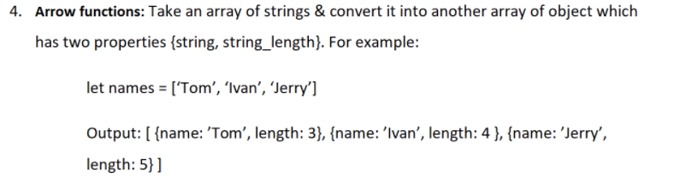

<!DOCTYPEhtml>

<html>

    <head>

        <title>demo</title>

    </head>

    <body>

        <h3>Arrow functions</h3>

        <script>

            letarray = ['Tom','Ivan','Jerry'];

            letnewArr = array.map(item=> {

                    return {

                        'name':item,

                        'length':item.length

                    }

                })

                document.write(newArr);

        </script>

    </body>

</html>

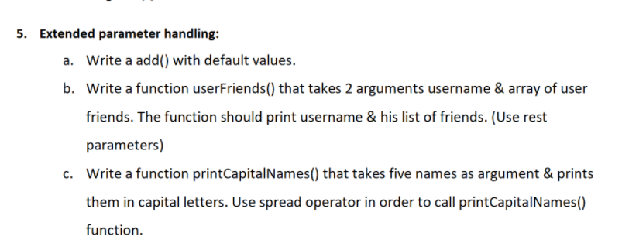

<!DOCTYPEhtml>

<html>

    <head>

        <title>demo</title>

    </head>

    <body>

        <h3>Extended parameter handling</h3>

        <scriptsrc=index.ts></script>

        </script>

    </body>

</html>

leta = function(value=10)

{

    returnvalue;

}

console.log('Default parameter is ' + (a()));

// b)

letuserFriends = function(username, ...userfriends){

    this.username = username;

    this.userfriends = userfriends;

    console.log(username,userfriends);

}

userFriends("Puja","kumari","lily","divya");

//c)

constnames =["puja","kumari","lily","divya","anu"];

letprintCapitalNames = function(){

    constx = names.map(function(name){

        returnname.toUpperCase();

    })

    console.log(x);

}

printCapitalNames();



<!DOCTYPEhtml>

<html>

    <head>

        <title>demo</title>

    </head>

    <body>

        <h3>Template literals</h3>

        <scriptsrc=index.ts></script>

        </script>

    </body>

</html>

constnames = "puja";

constdeskno = 100;

constlaptopmodel = "hp";

constmessage = "Hello SYSNET, My name is ${name}, desk number is ${deskno}, and laptop model is ${hp}."

"Here i am facing some issue to install the softwares it is asking admin rights to install, will u please resolve this error."

"Thanks and regards"

"Nerella Jhansi Aneela"

console.log(message);

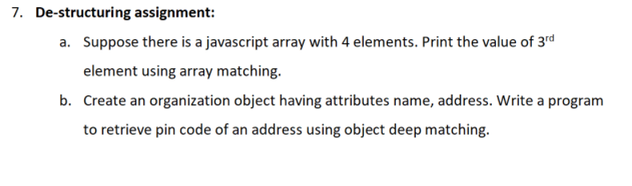

<!DOCTYPEhtml>

<html>

    <head>

        <title>demo</title>

    </head>

    <body>

        <h3>Destructuring Assignment</h3>

        <scriptsrc=index.ts></script>

        </script>

    </body>

</html>

**7-a)**

letfriends = ["puja","anu","lily","divya"];

let[item1,item2,item3,item4] = friends;

console.log(friends);

**7-b)**

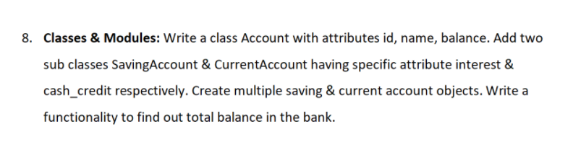

<!DOCTYPEhtml>

<html>

    <head>

        <title>demo</title>

    </head>

    <body>

        <h3>Classes & Modules</h3>

        <scriptsrc=index.ts></script>

        </script>

    </body>

</html>

classAccount{

    constructor(id,name,balance)

    {

        this.id = id;

        this.name = name;

        this.balance = balance;

    }

}

classSavingsAccountextendsAccount{

    constructor(id,name,balance,interest)

    {

        super(id,name,balance);

        this.interest = interest;

    }

    totalBalance = () =>{ this.balance += this.interest;

        console.log(this.balance);};

}

classCurrentAccountextendsAccount{

    constructor(id,name,balance,cashCredit)

    {

        super(id,name,balance);

        this.cashCredit = cashCredit;

    }

    totalBalance = () =>{ this.balance += this.cashCredit;

        console.log(this.balance);};

}

letS1 = newSavingsAccount(1001,'puja',40400,4000);

letS2 = newCurrentAccount(10003, 'anu', 30000,3800);

S1.totalBalance();

S2.totalBalance();